Alexander Cannell

CSIS 2600

Rob Robertson

1/31/12

Project 4-1

1.

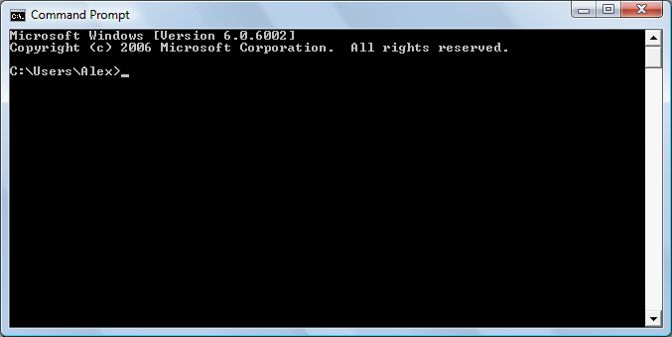

I opened command prompt

2.

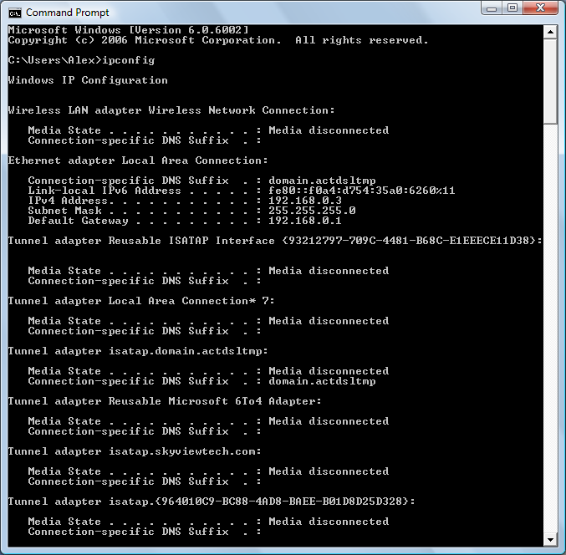

I typed ipconfig into the command prompt.

3. ipv4=192.168.0.3/subnet=255.255.255.0/gateway=192.168.0.1

4.

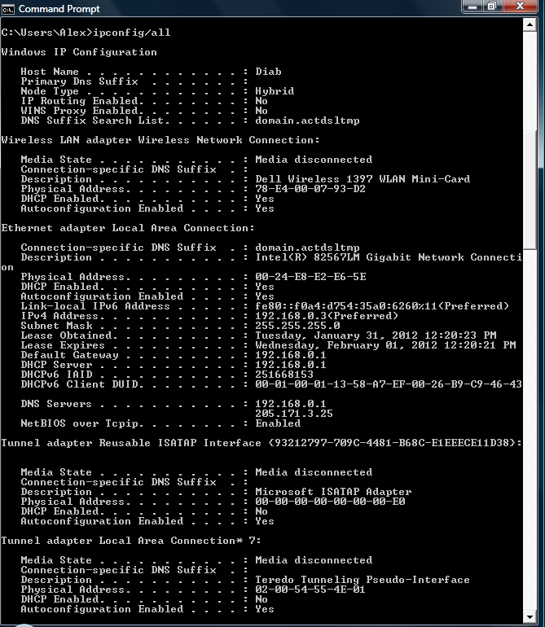

I typed in ipconfig/all into the command prompt

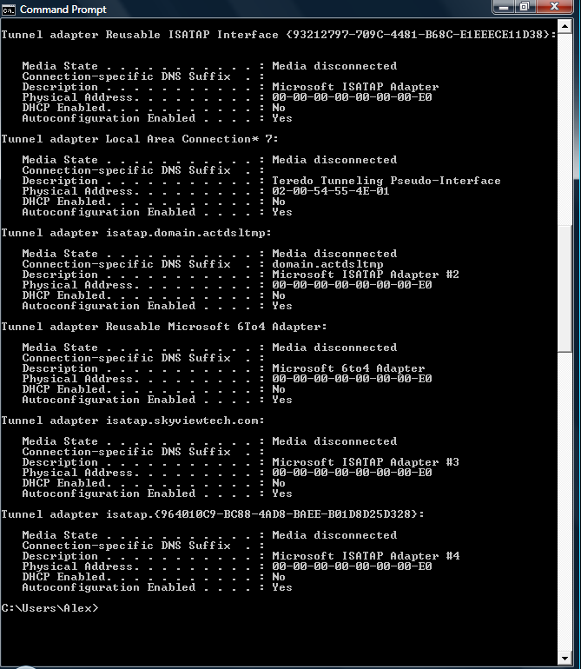

5. dhcp = 192.168.0.1-205.171.3.25/MAC=192.168.0.3-255.255.255.0

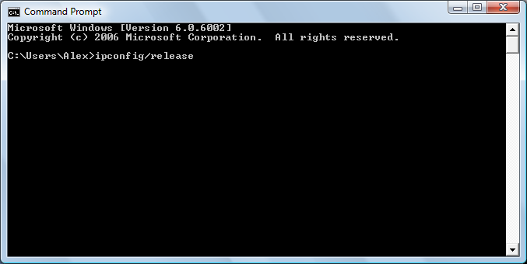

Ipconfig/release releases the dhcp license or lease.

7.

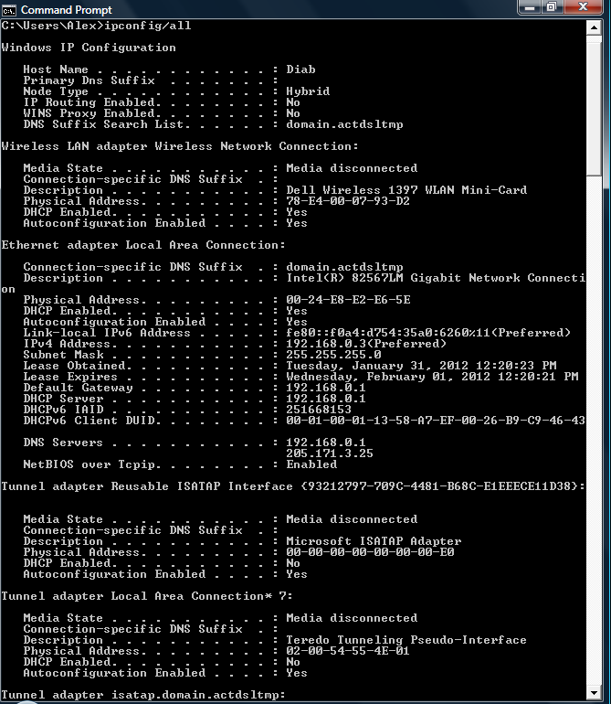

8.

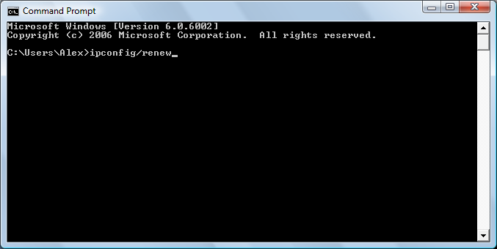

Ipconfig/renew renews the dhcp license or lease.

9.

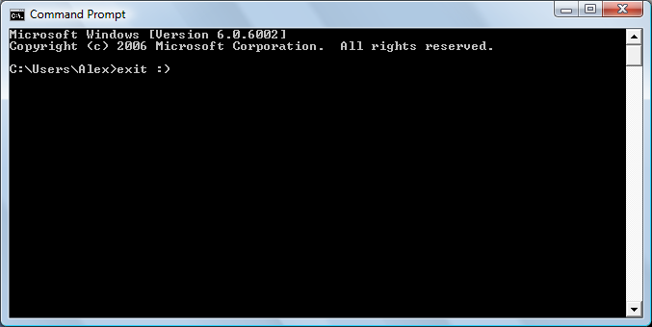

Typed exit to exit command prompt.

Project 4-2

1.

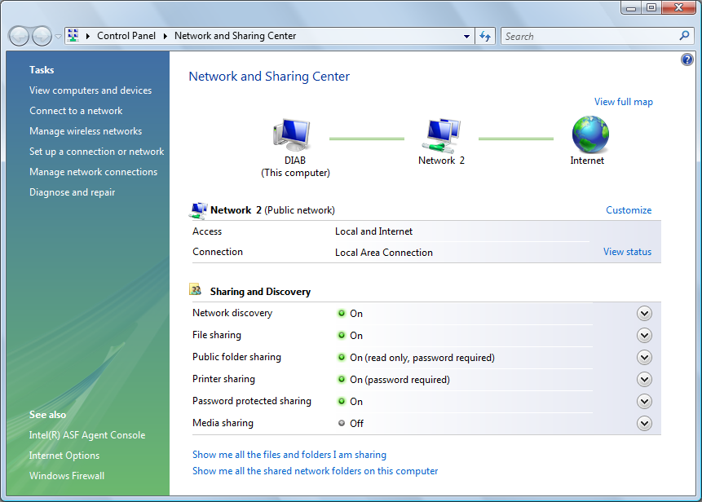

Opening the network and sharing center

2.

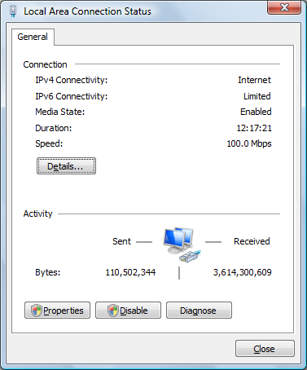

Open the network status window.

3.

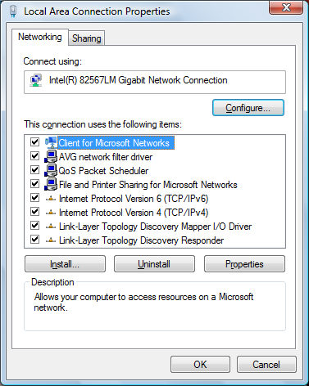

Local area network proberties.

4.

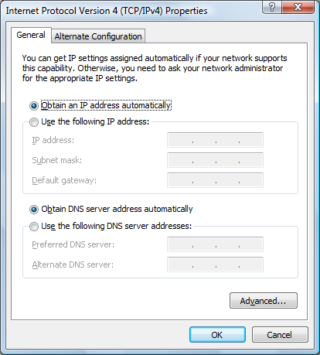

Tcp/ipv4 properties, with settings all on obtain.

5.

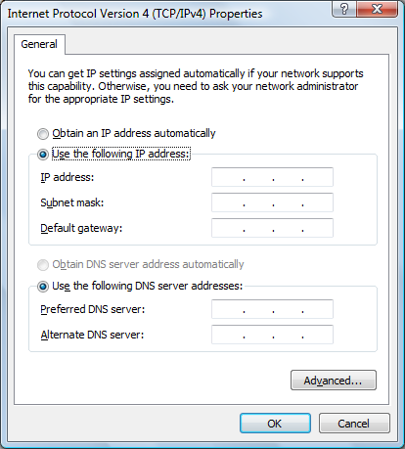

Changing from obtain to input a ip address.

6.

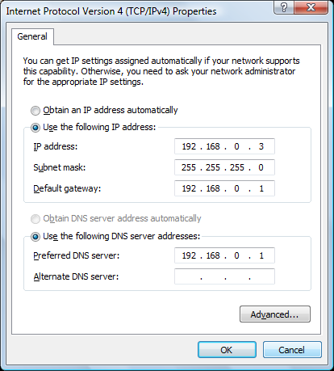

Inputting ip address.

7.



Ipconfig/all results after setting ip.

8.



Setting it back to obtain.

Project 4-3

1.

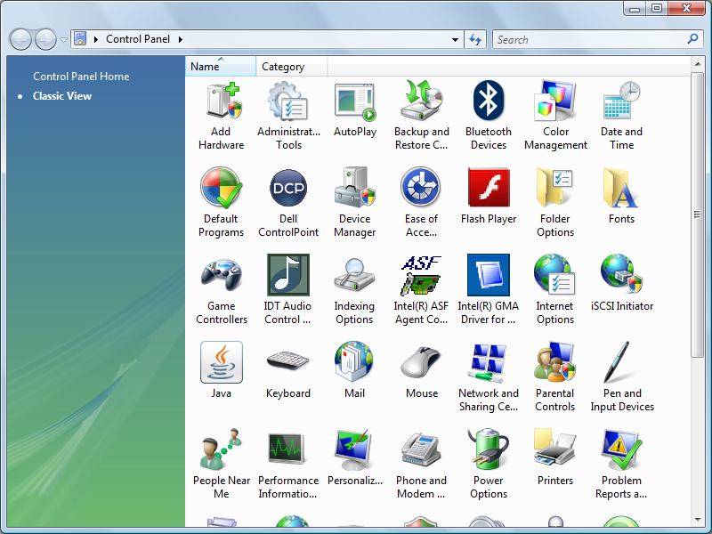

2.

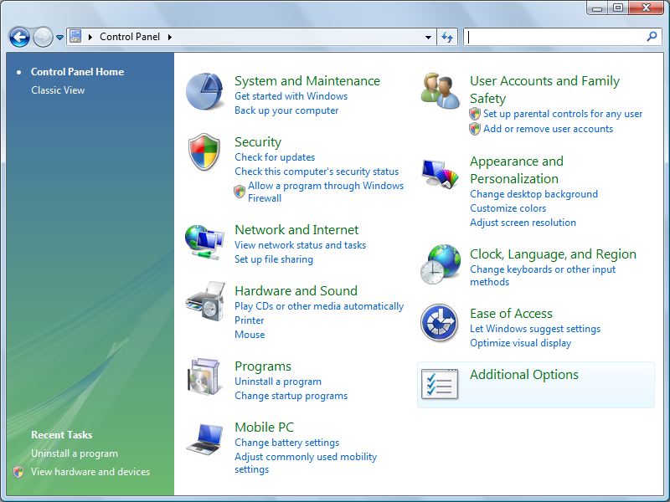

Opening the control panel

3.

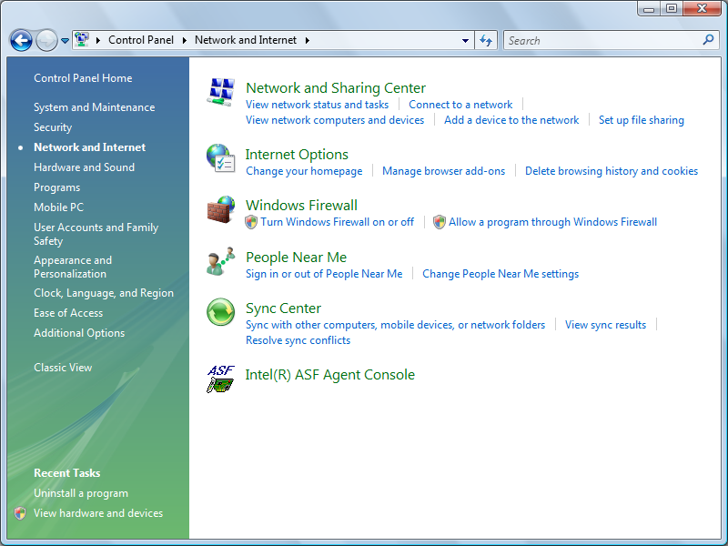

Opening from control panel, network and internet.

4.

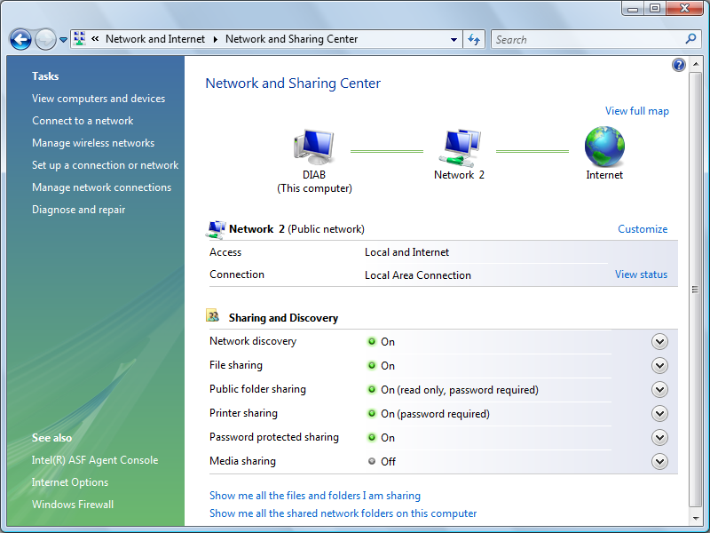

Opening network and sharing center.

5.

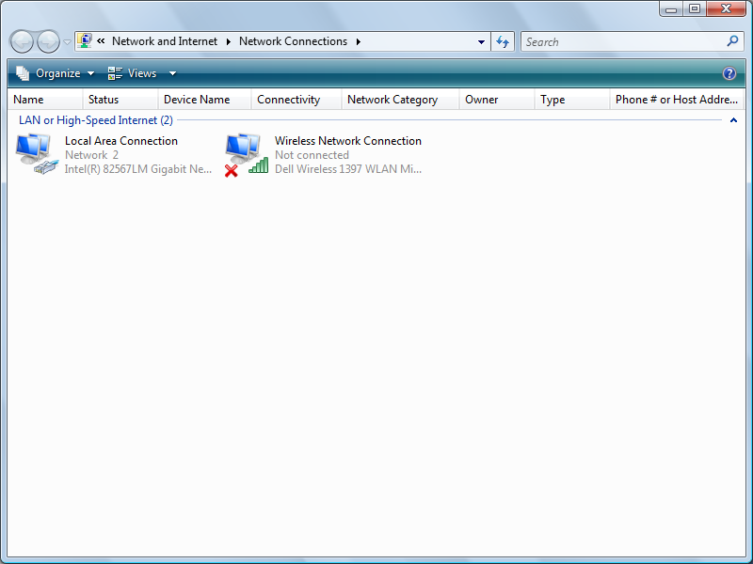

Opening Network connections

6.

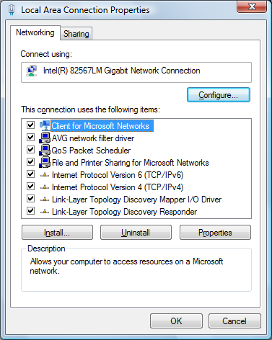

Opening local area connections properties.

7.

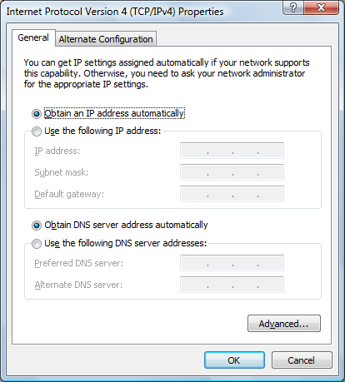

Viewing the TCP/IPv4 and how it’s on obtain.

8.



Using the TCP/IPv4 to manually input your static ip.

9.



Viewing ipconfig/all in command prompt

10.



Setting settings back to obtain.

Project 4-4

1.

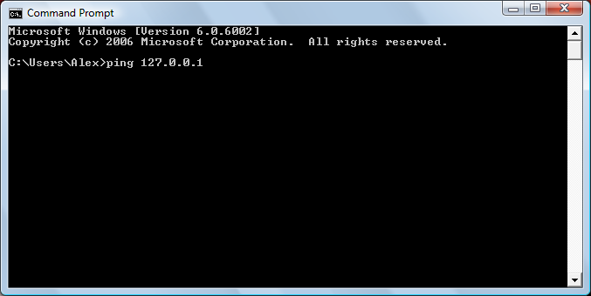

Showing me pinging 127.0.0.1

2.

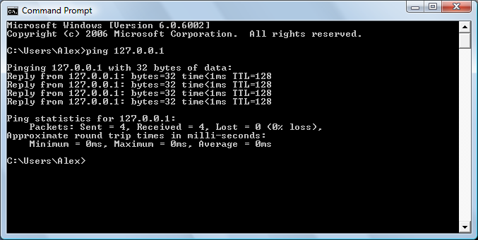

3. The TTL = 128, TTL means time to live, which is a number that indicates the maximum time that a datagram or packet that can remain on the network before getting discarded.

4. 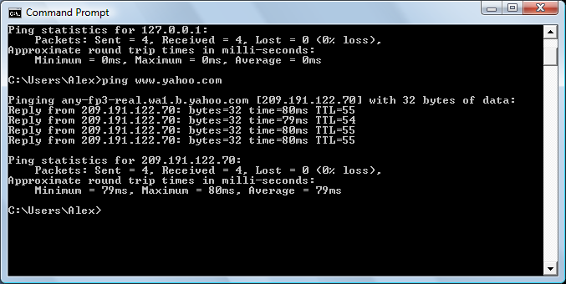

5. The TTL is 54 and 55, and the ip address is 209.191.122.70. the ping sent 4 and received 4 packets.

6. 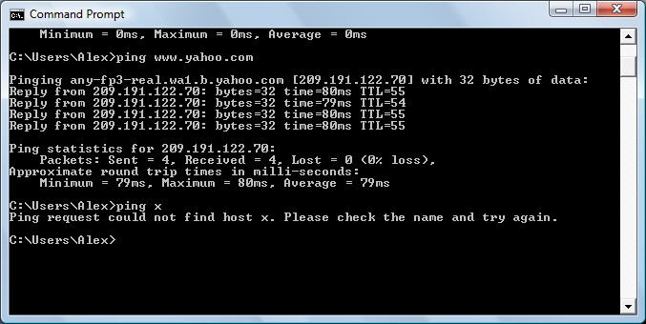

Ping couldn’t find x try again.

7. 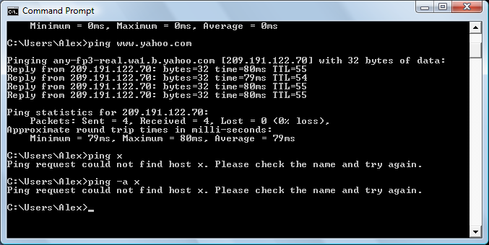

Ping couldn’t find-a x.